Introduction to Deep Learning



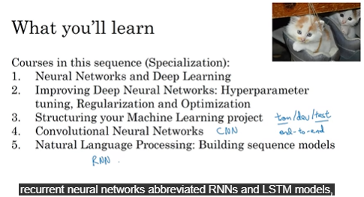

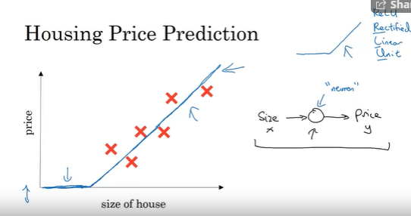

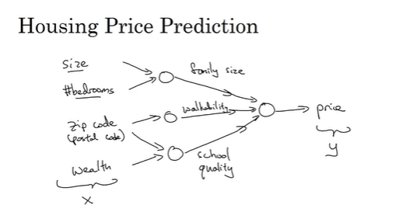



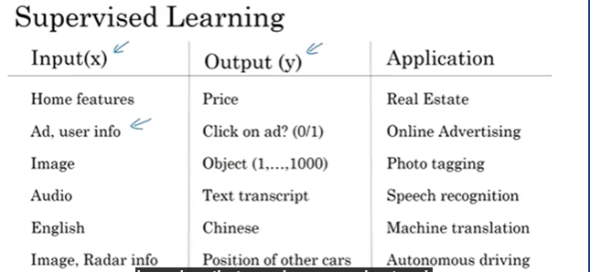

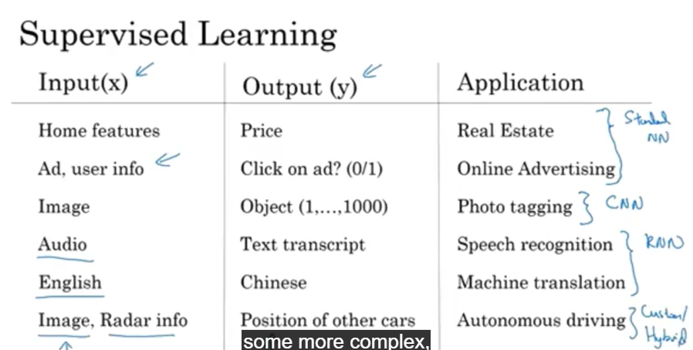

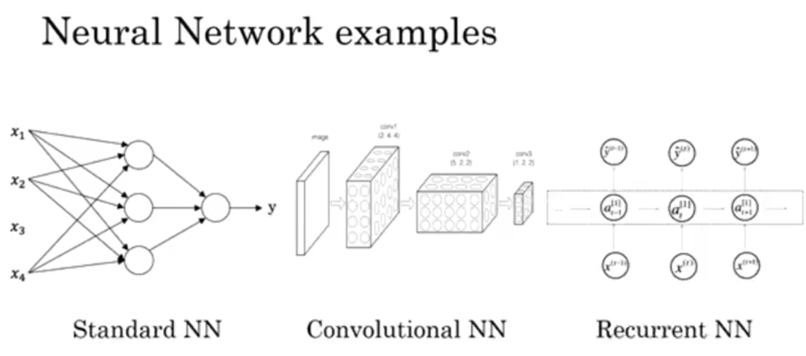

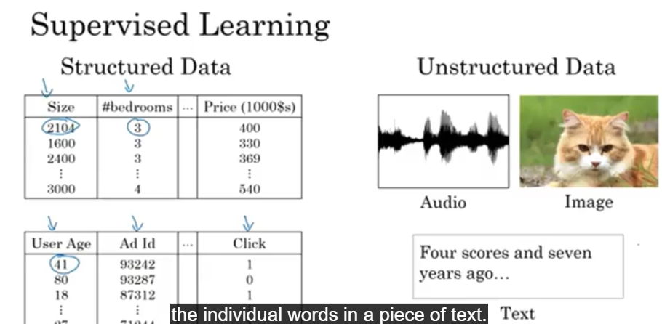

Deep Learning has been going on for ages but has become more effective recently. Choosing x and y is critical to deciding how good the result can be.

The common applications of types of Neural networks is as mentioned below:

1. Standard Neural networks: Real Estate, Online Advertisement
2. Convolutional Neural Networks: Photo Tagging
3. Recurrent Neural Networks: Speech Recognition, Machine Translation
4. Custom/ Hybrid Neural Network: Autonomous Driving

Why is Deep Learning hot right now?

Scale drives deep learning progress.

